Contact Manager
Ideation Phase
Brainstorm & Idea Prioritization

Date | 17/02/2026
Team ID | SWTID-2026-4180
Project Name | Contact Manager
Maximum Marks | 4 Marks

Brainstorm & Idea Prioritization

In the brainstorming stage, our team discussed different ideas for our project. Each member shared some suggestions based on what we learned in class and what type of application would be useful.

Some of the ideas discussed were Task Manager, Notes App, Contact Manager, and Reminder System. We talked about the features that each project could have and how difficult it would be to develop.

While discussing these ideas, we also thought about the technologies we are using in our project, especially MongoDB for storing data. We wanted to choose a project that is simple, useful, and easy for us to develop within the given time.

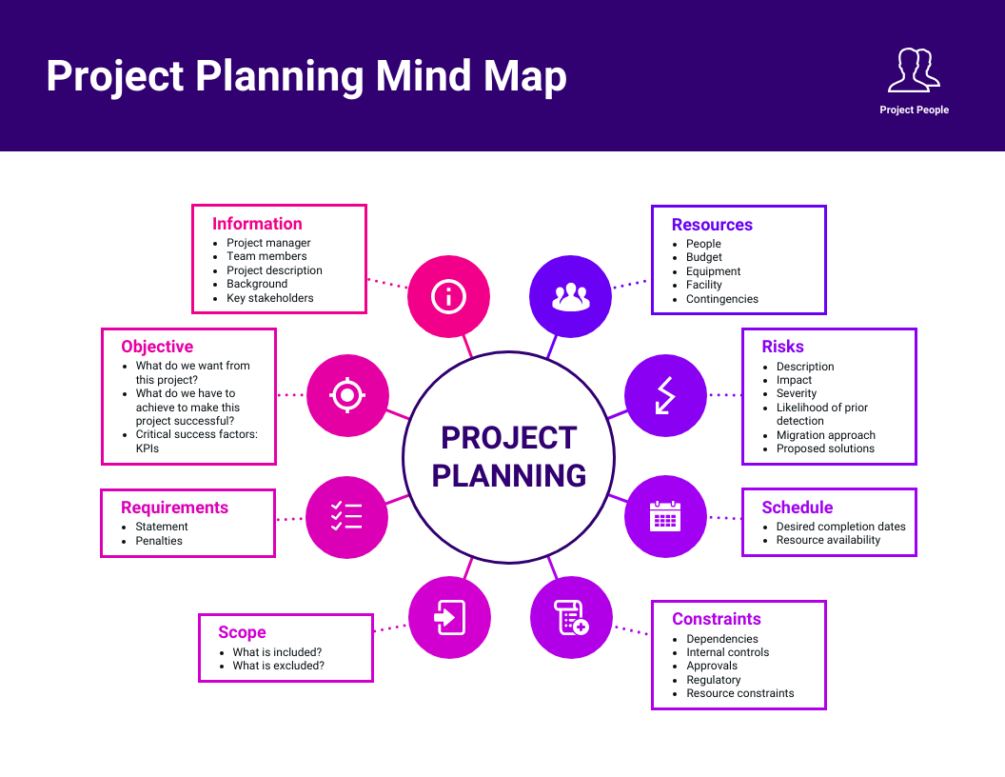
Ste 2 : Idea Prioritization
After brainstorming different ideas, our team evaluated each idea carefully. We considered factors like usefulness, simplicity, and development time.

Among all the ideas, we felt that Contact Manager would be the best project. This application helps users to store and manage their contact details such as name, phone number, and email address.

The Contact Manager is useful because it helps people keep their contacts organized in one place. It is also simple to build and suitable for our current knowledge level.

